
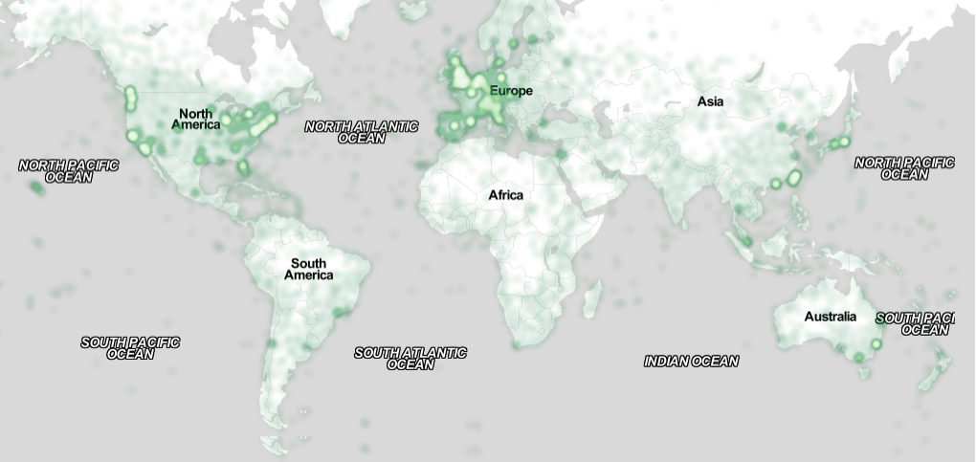
SIGCHI Conference Proceedings Format
Saad Ahmad  Chalmers University of Technology  Gothenburg, Sweden  TODO: e-mail address | Charlotte Boddien  Chalmers University of Technology  Gothenburg, Sweden  boddien@chalmers.se | Anne Labatut  Chalmers University of Technology  Gothenburg, Sweden  TODO: email address
Oskar Larsson  Chalmers University of Technology  Gothenburg, Sweden  TODO: e-mail address | Arnaud Perrin  Chalmers University of Technology  Gothenburg, Sweden  TODO: e-mail address

Project concept
For this project, our goal was to develop an Android mobile phone application that would make it easier and faster to find free seats in the Gothenburg library. For this, a booking system needs to be in place, where people can quickly and easily “check in” whenever they use a seat, so that the app knows which seats are empty and can be offered to people looking for a place to sit. To further facilitate the finding of suitable seats, a search function was implemented which allows users of the app to filter available seats to meet their needs. These could be availability of power outlets, a library computer available or the number of available seats at the same desk for group work.

Author Keywords
QR reader; seat finder; interactive design; mobile computing; Gothenburg library; maps

ACM Classification Keywords
Google Maps; Software and its Engineering; Software creation and management; Designing Software; Human-centered Computing; Usability Testing; Interaction Devices; Interactive Systems and Tools; Interaction design pocess and methods; Ubiquituous and mobile computing

INTRODUCTION
[Introduction to the context of the design]
The Gothenburg City Library is not just a place for books, it is also a place for people. The library provides plenty of spaces for people to sit – either alone or in groups – and to read, work, or interact. The seats are as varied as the reasons people might come to the library.
The PLACED project is concerned with creating digital services to “help libraries transform into vibrant urban innovation hubs by supporting knowledge creation activities among citizens and turning this knowledge into an ever-growing part of the urban community's shared resources”. [TODO: make proper reference: http://placedproject.eu/about-placed/]

Problem Statement
Anyone who has ever tried to find a seat in a library during busy hours will know that it can be quite tricky and take a long time. Especially if the library is big it can be hard to get an overview over where seats are even located and whether or not they are free. This gets further complicated when the person searching for a seat has special requirements for it, too. Maybe they don't just need a seat, but also a computer, a power outlet or natural light to be able to do their work. Or maybe there is a group of people looking to sit next to one another to do group work together. Finding seats that meet all of the requirements and are available can take a long time. The aim of our application is to reduce that time, by offering an interactive map that quickly gives its users an overview over where available seats meeting their specific requirements are located in the building of the Gothenburg City Library.

Background and related work
The online application Spacefinder [TODO: proper reference: https://spacefinder.lib.cam.ac.uk/] was made for a very similar purposes. It helps its users – especially students – find spaces to sit and work in Cambridge. Places where people can sit are marked on a map and can be clicked to receive more information about the location. A click reveals a short description and the type of the place (mostly cafés, bars and libraries spaces) as well a photo giving the user a feel for the location and a series of icons specifying additional properties of the seats – like internet access, day light, large desks or nearby toilets. It should be noted however, that this application offers this information strictly per location, not per seat. One room might have several different kinds of seats – e.g. a library room might have have a number of seats with computers and a number of seats without. The Spacefinder does not differentiate between these seats. This is where our application should differ. Since we focus on just one building, we can offer more fine-grained information about each seat. Using icons to display the different properties as well as the ability to filter locations by these strikes us as a very efficient way to help users find the spaces they need.
[TODO: describe the parking app that we used as references. Talk about what we copied for our app and why, talk about what we changed and why. What are we doing that those apps are not, what are we providing that was previously lacking?]

Concept
The Seat Finder app offers users an interactive map showing currently available seats in the Gothenburg City library. The user is able to filter these seats according to their specific needs – like needing a power outlet near the seat, or wanting to be allowed to eat in the area. The app then offers only those seats meeting their requirements and helps the user to find them. The user then walks to the seat(s), and to claim it/them, he scans one of the seats. For this, each seat has its own QR code attached to it, which the user can easily scan through the Seat Finder app. Once the seat has been scanned, it is booked for the next hour and displayed to other users as taken. Users can renew their booking at any time, if they intend to stay for longer than an hour. When users leave their seats, they are encouraged to unbook their seat, but if they don't the seat will be automatically freed again once the booking time has run out.
All interactions to do with booking and unbooking need to be very easy and quick, to encourage users to actually use them. For the concept of the application to work, it is crucial that users actually book and unbook their seats.

Design Process
[the design process and critical design decisions made]
[describe how we designed the prototype (we looked at similar apps: What did we copy and why? Which tools did we use for the prototype?]
[insert pictures of the screens we designed for the user test]
[Describe the user tests and what we learned from then → what did we change in our design?]
Figure 1. Sample of a wide figure. Be sure to place at the top or bottom of the page. Ensure that important information is legible in both black-and-white and color printing. Image: CC-BY-ND ayman on Flickr.

Implementation Method
[how the project was realized, including a description of the technology behind it (both software and hardware)]
For the implementation of the Seat Finder app, we used Android Studio. For the library map displaying the available seats, an empty Google Map was used, onto which we projected an overlay with the blueprint of the current floor of library building. This allows the user to zoom, rotate and move around the map as they would be used to from other applications. Google Map Markers indicate where the seats are in the building, and also whether or not they are available, the markers are green if the corresponding seat is free, and red otherwise.
[TODO: Describe how the QR scanner and the database were implemented.]
Because of the limited time available for this project, not all features of the app were fully implemented. The positions of the seats in the building and their attributes were invented freely by us, and the database … [TODO]
[What else did we fake?]

Evaluation
[evaluation against goals (use cases and results)

Limitations
Because we did not base the seats and their attributes on real seats in the Gothenburg City Library, the app is in its current shape not actually useful for finding seats in the library. The real seats would need to be carefully examined and fed into the app's database. Ideally, this database would be kept up to date by library staff in case seats are moved.
It is also as of now not possible to set a time for how long you want to book your seats yourself. If a user knows that they want to stay for much longer or shorter than an hour, this would be a useful addition.
The app also does not include information about events taking place at the library. Some of the seats on the map might be in use/available for a specific event, like a reading circle for children. Ideally, the app should display this information, too.
Another big limitation of the Seat Finder is that in its current state it requires more of less every user of the library to have the app installed and to use it every time they use a seat. This is not entirely realistic. A possible solution might be to provide buttons on the seats themselves, or to install sensors that can detect if a seat is in use, which would allow for alternative ways to mark a seat as booked or available.

Discussion
[discussion: what worked, what did not, possible improvements, interesting findings, etc]

Conclusion
[conclusion, lessons learned]

ACKNOWLEDGMENTS
Sample text: We thank all the volunteers, and all publications support and staff, who wrote and provided helpful comments on previous versions of this document. Authors 1, 2, and 3 gratefully acknowledge the grant from NSF (#1234-2012-ABC). This is just an example.

REFERENCES
Examples:
@_CHINOSAUR. 2014. VENUE IS TOO COLD. #BINGO #CHI2016. Tweet. (1 May, 2014). Retrieved February 2, 2014 from https://twitter.com/_CHINOSAUR/status/461864317415989248
ACM. How to Classify Works Using ACM’s Computing Classification System. 2014. Retrieved August 22, 2014 from http://www.acm.org/class/how_to_use.html
Ronald E. Anderson. 1992. Social impacts of computing: Codes of professional ethics. Soc Sci Comput Rev 10, 2: 453-469.
Anna Cavender, Shari Trewin, Vicki Hanson. 2014. Accessible Writing Guide. Retrieved August 22, 2014 from http://www.sigaccess.org/welcome-to-sigaccess/resources/accessible-writing-guide/
Morton L. Heilig. 1962. Sensorama Simulator, U.S. Patent 3,050,870, Filed January 10, 1961, issued August 28, 1962.
Jofish Kaye and Paul Dourish. 2014. Special issue on science fiction and ubiquitous computing. Personal Ubiquitous Comput. 18, 4 (April 2014), 765-766. http://dx.doi.org/10.1007/s00779-014-0773-4
Scott R. Klemmer, Michael Thomsen, Ethan Phelps-Goodman, Robert Lee, and James A. Landay. 2002. Where do web sites come from?: capturing and interacting with design history. In Proceedings of the SIGCHI Conference on Human Factors in Computing Systems (CHI '02), 1-8. http://doi.acm.org/10.1145/503376.503378
Psy. 2012. Gangnam Style. Video. (15 July 2012.). Retrieved August 22, 2014 from https://www.youtube.com/watch?v=9bZkp7q19f0
Marilyn Schwartz. 1995. Guidelines for Bias-Free Writing. Indiana University Press.
Ivan E. Sutherland. 1963. Sketchpad, a Man-Machine Graphical Communication System. Ph.D Dissertation. Massachusetts Institute of Technology, Cambridge, MA.
Langdon Winner. 1999. Do artifacts have politics? In The Social Shaping of Technology (2nd. ed.), Donald MacKenzie and Judy Wajcman (eds.). Open University Press, Buckingham, UK, 28-40.

Appendix: Technical Documentation and Project plan

